Abstract—In this study the author attempted to detect manatee calls in a signal which had the background noise of manatee’s usual habitat which is mostly underwater. The author used Least Mean Square Algorithm for this purpose and after fine tuning the models, achieved a 92% Area under the curve with Receiver Operating Characteristics (ROC).
Detecting Manatee Calls using Adaptive Filters
Purnendu Mukherjee

INTRODUCTION
Adaptive filters have been a cornerstone of Signal processing since decades now. While advanced methods such as Recurrent Neural networks and Convolutional Neural Networks are widely used for complex tasks such as speech recognition and image captioning, simple techniques such as Least Mean Squares still hold their ground in solving simple classification tasks with high accuracy.

In the problem at hand the author is interested in detecting manatee calls from a noisy underwater environment. This would have application in detectors that are able to detect manatees while boating so that manatees are not hit by boats or their accessories. The author had access to three types of data: the manatee calls that are without any background noise, the noisy background, and the manatee calls in their actual noisy environment with varying amplitude. The author implemented the Least Mean Square (LMS) algorithm to model the manatee calls as well as the background noise to be able to detect the manatee calls in the test signal.

The training signal has 10 manatee calls, separated with silence over a 25 second period. The sample noise data is of 2 seconds. The test signal is about 30 seconds with 16 distinct sounds but the author marked only 14 as 2 of the 16 calls were very faint.

the LMS algorithm

Least mean squares (LMS) algorithms are a class of adaptive filter used to mimic a desired filter by finding the filter coefficients that relate to producing the least mean square of the error signal (difference between the desired and the actual signal). It is a stochastic gradient descent method in that the filter is only adapted based on the error at the current time.

The basic idea behind LMS filter is to approach the optimum filter weights (R⁻¹P), by updating the filter weights in a manner to converge to the optimum filter weight. The algorithm starts by assuming small weights (zero in most cases) and, at each step, by finding the gradient of the mean square error, the weights are updated. That is, if the MSE-gradient is positive, it implies, the error would keep increasing positively, if the same weight is used for further iterations, which means we need to reduce the weights. In the same way, if the gradient is negative, we need to increase the weights. So, the basic weight update equation is:

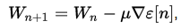

where epsilon represents the mean-square error. The negative sign indicates that, we need to change the weights in a direction opposite to that of the gradient slope.

The mean-square error, as a function of filter weights is a quadratic function which means it has only one extremum, that minimizes the mean-square error, which is the optimal weight. The LMS thus, approaches towards these optimal weights by ascending/descending down the mean-square-error vs filter weight curve.

The Approach of Detection and Application of LMS
As described before, the author had access to the manatee calls and the noisy data.
- The author decided to train two different models using LMS on these two signals.
- To be able to detect the manatee calls with high accuracy the models need to be trained and then the hyper-parameters of the models needs to be adjusted to increase the accuracy of the LMS filter. For this purpose, the manatee calls signal set was divided into training set and validation set. Section IV elaborates on this.
- Next, the LMS algorithm is run on the training data, i.e. both the manatee calls and the background noise to train the weights of the respective filters. Section V elaborates the process.
- The trained model with the chosen hyper parameters were applied on the validation set to further tune the parameters.
- The fine-tuned models were then applied to the test signal to find the detection results.

creating the validation set

To choose the optimum parameters such as the filter order and learning rate of the algorithm, the chosen parameters need to be verified after being trained. So, the training set was divided into a 7:3 ratio where 70% belonged to the training set and 30% for the validation.

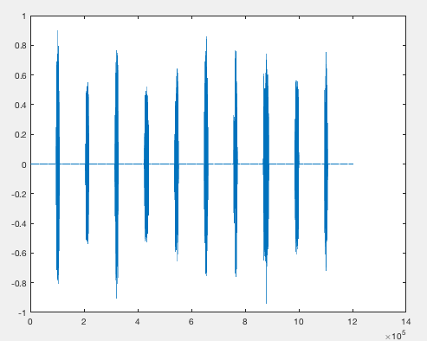

Fig. 1. The training signal with the 10 manatee calls.

The Power Spectrum Density of the above signal is as follows:
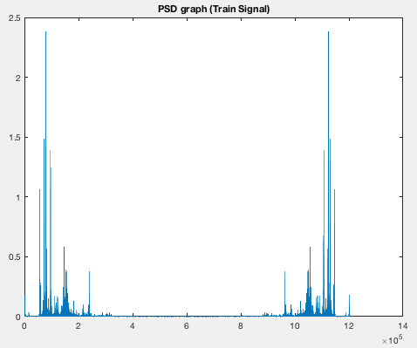

training the models
To train the two models the weights were computed over a range of learning rate step sizes and filter sizers. While the author experimented with a large range of values, only a few are mentioned here.

- Application on the Manatee Call Signal

Filter Size = [3, 5, 10, 15, 20];
Step Size = [0.01, 0.05, 0.1, 0.2]

The plots using the above values are as follows:

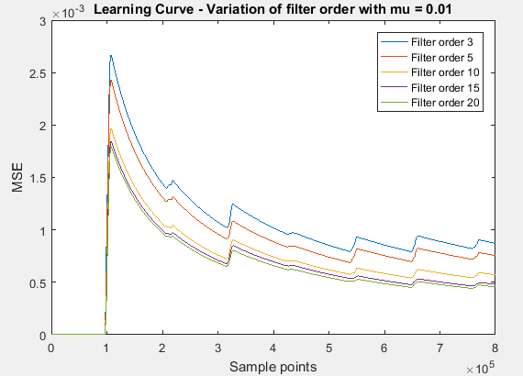
Fig. 4. Learning Curve of different filter sizes for step size =0.01

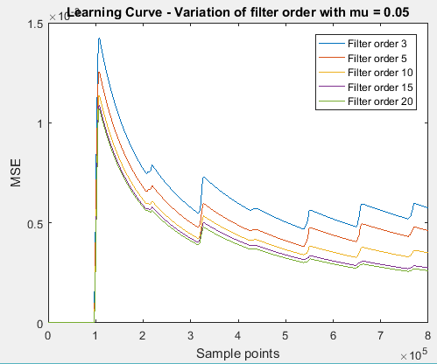
Fig. 5. Finding the best filter order with step size 0.05

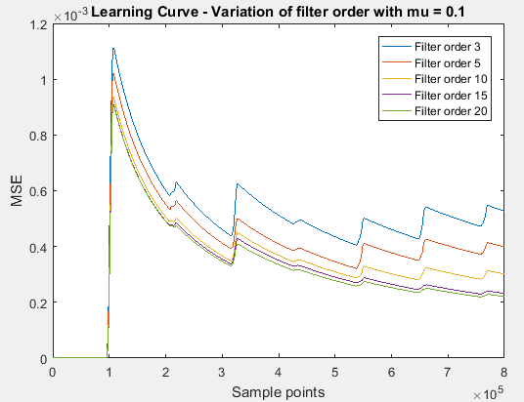
Fig. 6. Finding the best filter order with step size 0.1

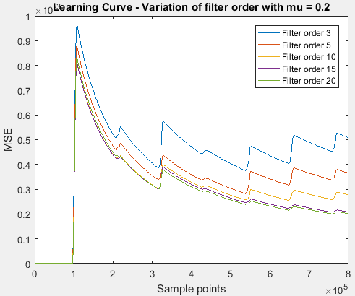
Fig. 7. Finding the best filter order with step size 0.2

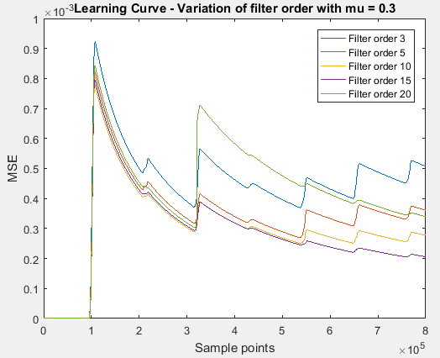
Fig. 8. Finding the best filter order with step size 0.3

From the above plots, we can see that filter order 15 would be the optimum choice with a learning rate of 0.3. The MSE at the end of the signal was calculated at 2.7931e-04.

We then check the convergence of the weights of the above chosen parameters.
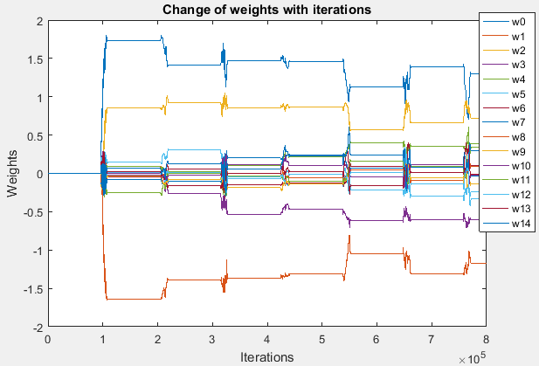
Fig. 9. Weights plot for filter size=15 and step size=0.3

Next, we apply the weights trained with the chosen parameters on the validation set.

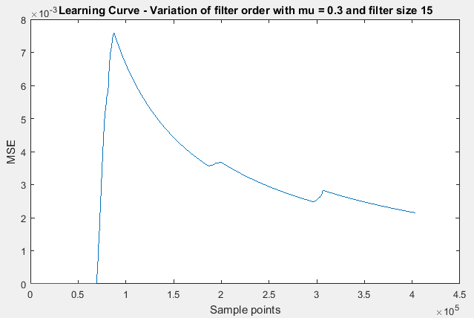
Fig. 8. Learning Curve with filter size=15 and step size=0.3

As before we see the MSE converging near 2 *10⁻³
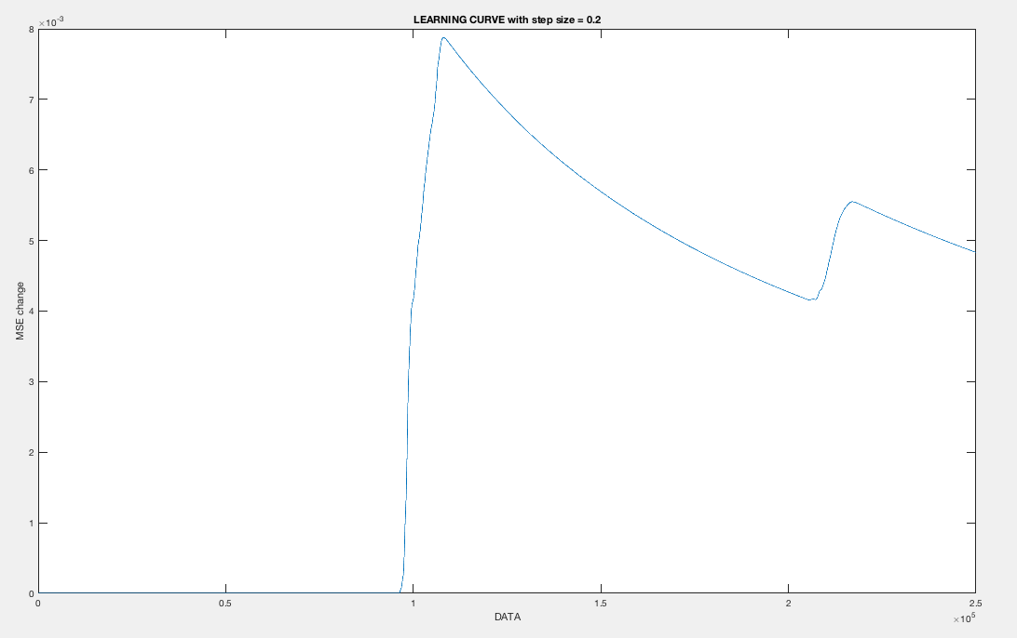
Fig. 10. Learning Curve for filter size=30 and step size=0.2 on the validation data.

- Application on the Noise data

Now that we have trained our first model we repeat the same process for the background noise data. I chose the following filter orders for evaluation.

Filter Orders: 3,5,10,15,20

The mu was checked over a large range. Some of them are mentioned here.

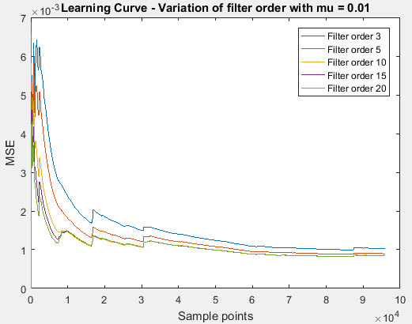

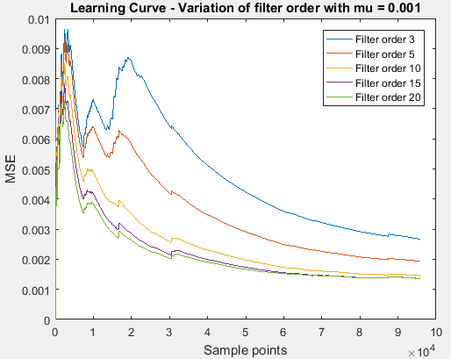

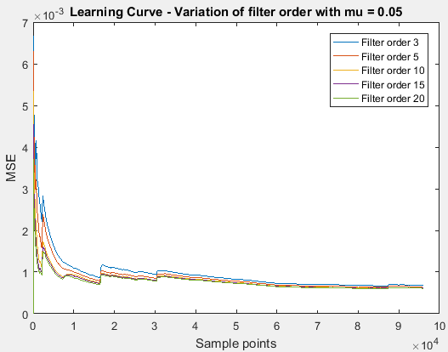

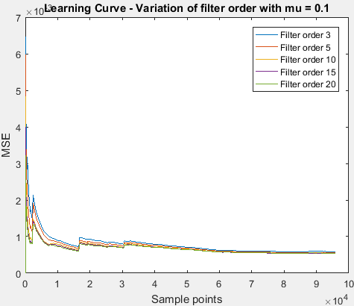

As before, I used the best corresponding filter size and step size that minimizes MSE for the validation data.

Weights plot for filter order 15 trained with mu = 0.1
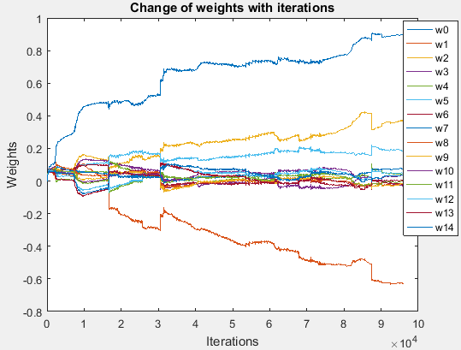
Fig. Weights plot for filter order 15 trained with mu = 0.1

From the observations, we see that all the filter orders converge at the same MSE value at the end of the learning curve. I chose filter size 10 for the noise filter to apply on the test set.

Results on application on the test set

Using the parameters and weights obtained from the training process, the algorithm is applied on the test set. The error values obtained after finding the difference between the test signal and predicted signal is noted for both the models. The error values are then smoothed by applying moving average on both the error vectors.
The ROC curve is generated for both the models and are as follows:

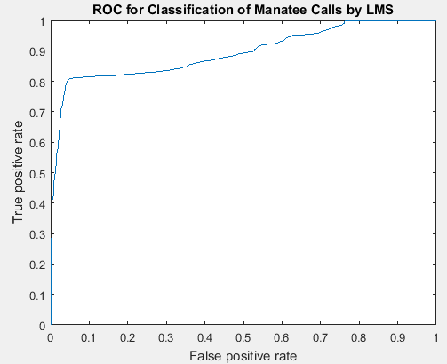
The Area under the curve for the manatee call signal is 0.8942.
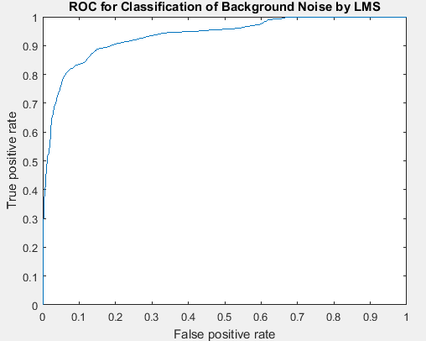

The Area under the curve for the background noise signal is 93.53.
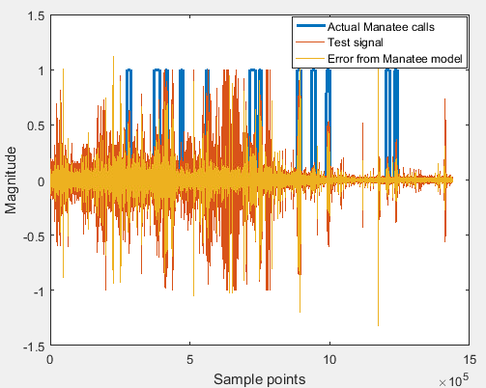

conclusion

The manatee signal model achieves high accuracy in detecting the manatee signals. This model can be extended to Neural networks as well to achieve even higher accuracy.

acknowledgement
The author expresses his gratitude towards the Professor and the TAs for their continuous help and support.

References
- Fast Implementations of the Filtered-X LMS and LMS Algorithms for Multichannel Active Noise Control, IEEE Transactions on Speech and Audio Processing, Volume 7, Number 4, July 1999.
- Vitor H. Nascimento and Ali H. Sayed, for the paper entitled, On the Learning Mechanism of Adaptive Filters, IEEE Transactions on Signal Processing, Volume 48, Number 6, June 2000.
- Wikipedia – Least Means Square.
- Simon Haykin: Adaptive Filter Theory, Prentice Hall, 2002, ISBN 0-13-048434-2
- Muanke, P. B. and Niezrecki, C., “Locating manatee position with an acoustic array,” 151st Meeting of the Acoustical Society of America, Providence, RI, June 5-9, 2006, Journal of the Acoustical Society of America, Vol. 117, No. 5, Pt. 2 of 2, May 2006, pp. 3405.
- Yan, Zheng, “Background Noise Cancellation for Acoustic Detection of Manatee Vocalizations,” Ph.D. Dissertation, University of Florida, Gainesville, FL, 2006.

 

